Project Design Phase-II
Technology Stack (Architecture & Stack)

Date | 15 February 2026
Team ID | LTVIP2026TMIDS35203
Project Name | visualization tool for electric vehicle charge and range analysis
Maximum Marks | 4 Marks

Technical Architecture:
The system architecture for the Wind Turbine Energy Prediction project integrates data preprocessing, machine learning model training, external weather API integration, and a Flask-based web application.
Example: Order processing during pandemics for offline mode
Reference: https://developer.ibm.com/patterns/ai-powered-backend-system-for-order-processing-during-pandemics/
Guidelines:
Include all the processes (As an application logic / Technology Block)
Provide infrastructural demarcation (Local / Cloud)
Indicate external interfaces (third party API’s etc.)
Indicate Data Storage components / services
Indicate interface to machine learning models (if applicable)
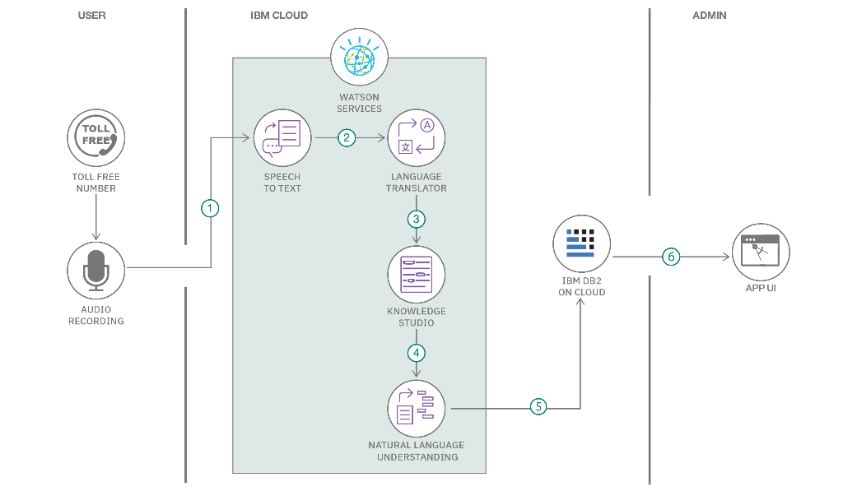

Table-1: Components & Technologies
S.No | Component | Description | Technology
1 | User Interface | Web interface for user interaction (intro page, prediction dashboard) | HTML, CSS, JavaScript, Flask Templates
2 | Application Logic-1 | Handles ML prediction requests (input → model → output) | Python (Flask, Pandas, Scikit-learn)
3 | Application Logic-2 | Weather data retrieval and processing | Python (Requests library, OpenWeather API)
4 | Application Logic-3 | Data preprocessing, training, evaluation, and saving model | Python (NumPy, Pandas, Matplotlib, Scikit-learn, Joblib)
5 | Database | Stores dataset (historical wind turbine data) | CSV files (local storage)
6 | Cloud Database | Optional extension for scalability | AWS RDS / MongoDB Atlas (future scope)
7 | File Storage | Stores trained model and datasets | Local filesystem (.sav, .csv)
8 | External API-1 | Fetches live weather conditions | OpenWeather API
9 | External API-2 | (Optional future integration) e.g., grid demand API | Energy Grid APIs
10 | Machine Learning Model | Predicts wind turbine energy output | Random Forest Regressor
11 | Infrastructure | Deployment environment | Local Server (Flask), Cloud-ready (Docker, Kubernetes, AWS/GCP/Azure)

Table-2: Application Characteristics
S.No | Characteristics | Description | Technology
1 | Open-Source Frameworks | Frameworks used for ML and web development | Flask, Scikit-learn, Pandas, NumPy, Matplotlib
2 | Security Implementations | Basic security for API keys, input validation, and server protection | API key encryption, HTTPS, Flask form validation
3 | Scalable Architecture | 3-tier architecture (UI → Flask backend → ML model) with cloud deployment | Flask + Docker + Kubernetes (future scope)
4 | Availability | Can be hosted on cloud with load balancers for high availability | AWS/GCP/Azure Load Balancers
5 | Performance | Optimized ML model, caching weather API responses, lightweight Flask server | Flask caching, CDN (future scope), Random Forest efficiency

This design phase shows your project as a professional architecture document:
- Table-1 captures the components and technologies.
- Table-2 highlights application characteristics like scalability, security, and performance.

